Market study on mitigation potential for heat pump and commercial refrigeration equipment in Ukraine

Authors: Regina Karakina, HEAT GmbH
Dietram Oppelt, HEAT GmbH
Edgar Timm, International Expert HEAT GmbH
Sergey Anashkin, PU RAU Ukraine
Oleg Khomenko, National Expert PU RAU Ukraine

Supervisors: Dr. Cornelia Elsner, UBA

Table of Contents
Acknowledgements 3
Kurzbeschreibung/Abstract 3
1 Introduction and objective 3
2 Background information on commercial refrigeration and heat pumps 4
2.1 Information for key growth drivers 4
3 Data acquisition 4
4 Legal and regulatory framework 6
5 Market for heating and commercial 6
5.1 Heating 6
5.1.1 Heat pumps as climate friendly heating technologies 6
5.1.2 Demand for heating and heat pump technology 7
5.1.3 Conventional vs climate friendly heat pumps with natural refrigerants 7
5.2 Commercial refrigeration 9
5.2.1 Commercial refrigeration technologies 9
5.2.2 Demand for commercial refrigeration equipment 9
5.2.3 Conventional vs climate friendly refrigeration equipment 10
6 BAU Mitigation scenarios 11
6.1 Emission saving potential with heat pumps 11
6.2 Emission saving with climate friendly commercial refrigeration equipment 12
References 12

Table of abbreviations

PU RAU | Public Union “Refrigerating Association of Ukraine”
HCFC | Hydrochlorofluorocarbon
HFC | Hydrofluorocarbon
UNHPA | Ukrainian National Heat Pump Association
LULUCF | Land Use, Land Use Change and Forestry
MENR | Ministry of Ecology and Natural Resources Ukraine
HC | Hydrocarbons
ODP | Ozone-Depleting Potential
ODS | Ozone-Depleting Substances

Acknowledgements

Kurzbeschreibung/Abstract

<to be inserted>

Introduction and objective

Despite the high level of technical education in Ukraine, the regulations and technologies in refrigeration and heating are strongly lagging behind the EU standards.
Use of old, inefficient and environmentally damaging (ozone depleting, high GWP) refrigeration and heating equipment is still the norm in Ukraine. The heating sector is largely dependent on the production and import of fossil raw materials from neighboring countries.
With 339 MtCO₂e as of 2016, Ukraine is currently one of the largest greenhouse gas emitters on the European continent, with 65% of emissions due to energy consumption. Ukraine is a party to the Montreal Protocol and, since entering into force of the Kigali Amendment as of January 2019, it is obliged to replace 97.5% of HCFCs and 85% of HFCs by 2030.
In the process of transition, Ukraine can strongly benefit from the experience of the EU and the established structure for the conversion of RACHP technologies through the EU F-gas Regulation (EU Reg. No. 517/2014).
The use of modern, energy-efficient heating and cooling technology in combination with climate-friendly refrigerants and renewable energies as well as the appropriate training of specialists will become an unavoidable step for Ukraine. The increased use of modern heat pumps can reduce dependency on imported fossil fuels and make a significant contribution to the decarbonization of the heating sector in the medium to long term.
For the current project, two subsectors with the biggest potential in the region – heat pumps and commercial refrigeration - were analyzed, including an assessment of historic, current and future market (sales and stock of units), the most important importers, manufacturers and installers.
The objective of the study is to assess the regulation framework as well as current state and size of the market in order to make an objective picture about the mitigation and energy saving potential of using technically feasible alternatives, specifically in these two subsectors in Ukraine.

Country background

Key growth drivers

Ukraine is a state in the East of Europe with a total population of ca. 42 mio., bordering Russia, Belarus, Poland, Slovakia, Hungary, Romania, Moldova and the Black Sea.

The urban population in Ukraine approximately doubles the rural one, with the biggest/most prominent cities being Kyiv (capital), Kharkiv, Odessa, Dnipropetrovsk, Donetsk, and Lviv.
Currently, Ukraine is in the middle of a political and an economic transition. The events of 2014 caused a crisis in many areas, leading to a drop in sales and to a longer-term split in politics, business and even religion within the country. Some progress has been made recently and economy started to grow again, but the rate of growth is still slow in comparison to neighbouring EU countries/member states.
Further development will require some international financing and strengthening of partnerships as well as contribution/involvement of the private sector. Active participation in European and global markets will be crucial to further competitiveness and growth of Ukraine.
Ukraine’s climate can be characterized as continental, with very cold winters and hot summers. Several studies indicate Ukraine’s climate has been changing …

Table 1: Background data and key indicators on Ukraine's economy (World Bank Statistics 2018)
Measure | Value | Units
Population | 44.6 | Million
Number of households
GDP | 130,832 | $ billion
GDP per capita
Inflation
Employment rate
CO₂ emissions | 5 | Metric tons per capita (data of 2014)

Data acquisition

Primary data

Primary data was gathered from associations, companies and industry representatives.
Main participating stakeholders are:
- Members of the PU RAU: …
These companies represent ca. 70% of the (commercial) cooling sector.
Supermarkets/retail chains
- The Ukrainian National Heat Pump Association (UNHPA)

Secondary data

Secondary data was gathered from various sources:
- Studies conducted by European organizations (EBRD)
- National report on ODS compiled by the UNDP;
- Customs data;
- National reporting (National communication, Biennial Update Reports);
- Studies of individual companies;
- Studies from intelligent services BSRIA, JRAIA, Euromonitor

Legal and regulatory framework

Regulations and status on climate protection

Ukraine has committed to multiple international climate-related agreements. It is Annex I Party to the UNFCCC since 1997 and has been an active participant in negotiation processes. It is also an Annex В Party to the Kyoto Protocol since 2004. 47 million Assigned Amount Units (in total three deals in the industry sector) under the Green Investment Scheme in the framework of Kyoto Protocol have been issued between 2008-2012, which allowed the government to sell their emission rights and use the revenue to invest into green projects. In 2014, further climate-related obligations were determined in accordance to EU-Ukraine Association Agreement (2014).
These efforts allowed Ukraine to establish the first frameworks and necessary institutional arrangements to set up and implement GHG mitigation projects; however, those implemented so far have not reached the necessary emission reductions. Ukraine ratified the Paris Agreement in September 2016. In its first Nationally Determined Contributions (NDC) submitted in 2015, Ukraine declared its intention to reduce GHG emissions by at least 40% below 1990 levels (including LULUCF) by 2030. Ukraine’s NDC covers energy, industrial processes and product use, agriculture, LULUCF and the waste sector, but does not specify the mitigation contribution of each sector.
Ukraine has imposed a carbon tax on stationary sources in the industry, power and buildings sectors, which was increased tenfold in 2018 (0.02 to 0.36 USD/tCO2) effective from January 2019 and further increases are planned. It is still the lowest carbon price rate worldwide (Worldbank and Ecofys 2018).
In 2018, Ukraine published its 2050 Low Emission Development Strategy (LEDS) stating that the emissions in total 2050 should not be more than 35% of 1990. The LEDS sets the 2° target as the reference value for its defined goals. The three objectives described in the LEDS are:
- energy transition to low-carbon energy sources and increase in energy efficiency and clean transport;
- increase in carbon absorption through agricultural practices and forestry;
- reduction in methane and nitrogen oxide emissions.
LEDS also defined concrete policies and measures for the sectors energy efficiency, renewable energy, modernization and innovation (industry), market mechanisms, the process of extraction, processing, transportation and storage of fossil fuel, waste treatment and agriculture were set.
…

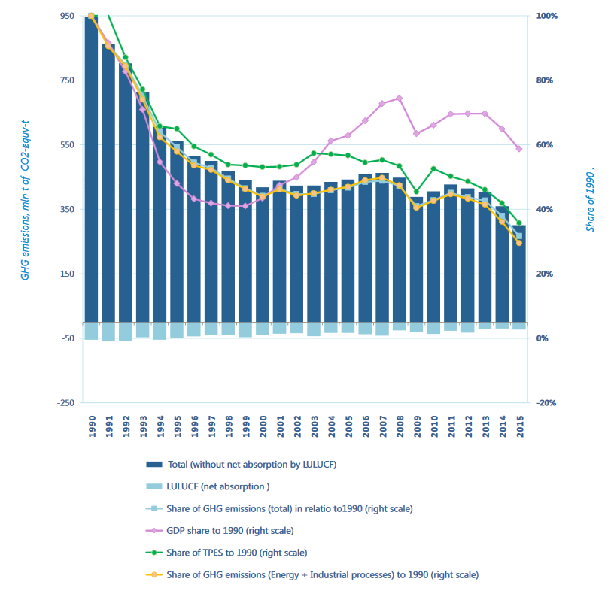
Figure 1: Ukraine's economic, energy and climate performance from 1990 to 2015 (LEDS)
Since 2015, GHG emissions in Ukraine have been rising again. About 65% of current emissions come from the energy sector, followed by industry, agriculture and waste.

Regulations and status on fluorinated gases and refrigerants

The draft of the “Law on ozone-depleting substances and fluorinated greenhouse gases” was proposed by the PU RAU to the Verkhovna Rada (Parliament) of Ukraine, the central governing body which will make the decisions on the 14th of September 2018. Until now, the draft law is still under revision.
There are three key messages which are contained in the proposed law:
- Introduction of time limits on the preparation of implementing regulations;
- Introduction of financial/economic incentives for companies to purchase new refrigerants and the respective equipment, such as tax exemptions/reductions;
- Management of disposal and recovery of refrigerants, subsidies from the government for transport and utilization of old substances.
In the near future, further restrictions regarding import of HFC-containing equipment as well as substances themselves from other European countries will become a critical limitation for trade. Therefore, it should be a priority to introduce laws governing phase-out of F-gases and work on a concrete action plan for Ukraine. Experiences of other (neighbouring) countries can be taken into account.
There was a project on Initial Implementation of Accelerated Hydrochlorofluorocarbon (HCFC) Phase-Out in the Countries with Economy in Transition (CEIT) Region, implemented by the UNDP, which produced the draft law and the first report on ozone depleting substances.

….

At present time Ukraine has no takeback or recycling system for old refrigeration or heat pump equipment.

Regulations and status on energy efficiency and renewable energy

In general, the policies on energy efficiency and renewable energy are still made separately and are not well integrated in Ukraine.
The LEDS specify the following measures in energy efficiency:
- Increase of energy efﬁciency in buildings;
- Promotion of private and public ﬁnancing of measures aiming at increase in energy efﬁciency;
- Speciﬁc measures aimed at increase in energy efﬁciency in the use of electricity and heat energy and/or types of fuel in all sectors of Ukraine's economy;
- Incentives to use energy efﬁcient technologies in agroindustry;
- Incentives to use energy efﬁcient measures in the industry.

International financial institutions such as the EBRD, World Bank, NEFCO and EIB have been supporting Ukraine in implementation of energy efficiency projects.
The map of renewable energy resources has been dominated by biofuels&waste-to-energy and hydro. Current renewable energy share constituted ca. 4% of the total primary energy supply.
National Renewable Action Plan through 2020 (NREAP)
- Renewable share projected to increase to 12.4% in 2020, so far Ukraien is behind the targets
National Energy Efficiency Action Plan through 2020 (NEEAP)
- Energy saving quantitative targets for 2017 and 2020 are determined as 5% and 11% of the average TFC as compared to 2005-2009
Energy Strategy for Ukraine through 2035 (ESU)
- Total share of renewables in TPES in 2035 is approved at 25%

Table 2: Average Feed-in-tariffs as of September 2018, EUR/MWh
Small hydro | 116.5
Wind | 105.4
Solar | 203.7
Biomass | 117.4
Weighted average tariff | 154.0

Currently, renewable in Ukraine hardly compete with the highly subsidized gas prices.

The LEDS specify the following measures in renewable energies:
- Increase in output and consumption of electricity produced from renewable sources;
- Environmentally sustainable production and extension in the use of biomass (biofuel);
- Production of biogas and extension in its use for heat energy and electricity production;
- Development of Ukraine's sectors international integration in the sphere of renewable energy.

Heat Pump Regulations:

- 2018 Regulation by the Ministry of Regional Development, Construction, Housing and Communal Services of Ukraine: “On Approval of the Methodology for Calculating the Share of Energy Produced by Heat Pumps from Renewable Sources”

IQ energy is a facility to foster energy efficiency improvements in the Ukrainian residential sector in accordance with European energy efficiency standards. The programme was designed by the European Bank for Reconstruction and Development (EBRD) as part of the EU4Energy initiative and is supported by donors in providing technical assistance and incentives. Supported EE projects will consist of investments in high performing energy efficiency technologies and measures, which have at least a 20% higher energy performance than the market average.
In order to facilitate the search for EE products that are eligible for this financing, EBRD has set up two databases – the List of Eligible Materials and Equipment (Technology Selector) and the List of Suppliers and Installers (Supplier Selector). The technologies and materials included in the Technology Selector meet the high standards set out by EBRD, based on a proven methodology used in many countries. This information is available on a specialised website at www.iqenergy.org.ua/technologies. Technologies include windows, insulation, heat pumps, heating systems, boilers, solar, meters, front doors, heat recovery units.

Stakeholder Map

Key stakeholders in climate protection, energy efficiency and the RACHP sector in Ukraine are presented in the scheme below.
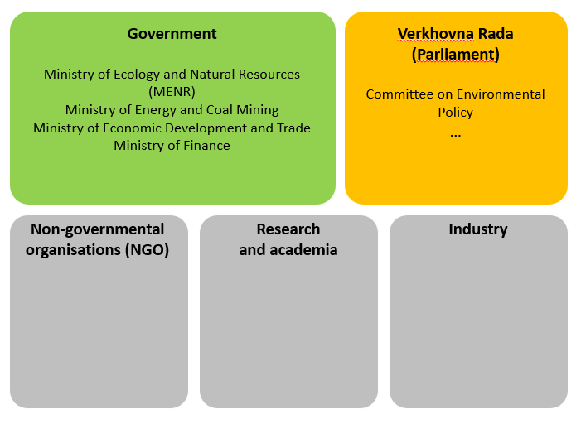

Table 3 Main stakeholders in the sector in Ukraine
Organization | Roles | Contact
Ministries
Ministry of Ecology and Natural Resources | Central executive body to form and implement the state policy on climate change and fluorinated gases, ozone
Ministry of Energy and Coal Industry (MinEnergy) | Policies on energy efficiency, energy strategy of Ukraine | http://mpe.kmu.gov.ua
Ministry of Regional Development, Building and Housing and Communal Services
Government institutions and organizations
National electricity regulatory commission of Ukraine (NERC) | Regulator | www.nerc.gov.ua
Renewable energy agency of Ukraine |  | www.rea.org.ua/en/contacts-en
State committee of building, architecture and housing | Regulations on energy efficiency in buildings and the residential sector
State statistics service of Ukraine | Statistics on imports and economical statistics | http://www.ukrstat.gov.ua/
State Agency on Energy Efficiency and Energy Saving of Ukraine | Energy audits
Research
Odessa National Academy of Food Technologies | Primary research institution on commercial cold applications | https://www.onaft.edu.ua/en/
Non-governmental organizations
Refrigerating Association of Ukraine (PU RAU)
National Association of Ukraine with heat pumps (UNHPA)

Private organisations and companies
Local manufacturers
Importers

Market for heating and commercial refrigeration

ODS and refrigerants

HCFC are still widely used in Ukraine, with R-22, 141b and 142b being the most widespread.

Table 4: Reporting on HCFC consumption in Ukraine (reports in the Ozone Secretariat, Mt)
HCFC/year | 2009 | 2010 | 2011 | 2012 | 2013 | 2014 | 2015
HCFC 21 | 0 | 0 | 0 | 0 | 0,04 | 0 | 0
HCFC 22 | 712 | 951 | 1500 | 1500 | 585,062 | 557,7256 | 82,518
HCFC 124 | 0,14 | 0 |  |  | 0 | 0 | 0
HCFC 141b | 102,8 | 229 | 300 | 300 | 202,5 | 68,496 | 4,600
HCFC 142b | 201,1 | 145 | 200 | 200 | 76 | 62,0568 | 0,8364
HCFC 406A | 0 | 0 |  |  | 0 | 119,776 | 0
HCFC С10M1-A | 0 | 0 |  |  | 0 | 31,28 | 0
Total net consumption of ODP, tonnes | 1015,6 | 1325 | 2000 | 2000 | 863,602 | 840,3344 | 87,9544
Total net ODP, tonnes | 63,5 | 86,9 | 80,4 (128,5) | 97,3 | 53,39 | 49,06 (50,86) | 5,1

Heating

Heat pumps as climate-friendly heating technologies

With demand and prices for fossil fuels rising, the heating costs for end users particularly in the industrial and residential sectors are going up rapidly.
At the same time, fossil-fuel related emissions are peaking and have to be mitigated as soon as possible to avoid catastrophic global run-away effects.
Therefore, the need and the market for alternative heating technologies such as heat pumps is expected see strong growth in the near future, globally and particularly in such energy-intensive economies as Ukraine.
Heat pumps are devices that use the heat energy of the air, ground and ground waters for heating building spaces or water. A heat pump directs the heat from various sources such as outside air or the ground into the building. Depending on the source, heat pumps are classified into the following types: ground-water, water-water, air-water and air-air. Especially in industrial processes, a lot of energy and costs can be saved by utilizing the excessive heat produced in the processes with a heat pump.
Energy efficiency is measured by the coefficient of performance (COP), the ratio of generated heat energy to the used electrical energy (the higher the better).
Technology options and characteristics:
- Commercial over 20 kW
- Large residential 10-20,
- Small residential 10
- Ground source /air source
Hydrocarbons are nowadays most commonly used in the heat pump circuit. They have a low GWP and meet the requirements of the EU F-gas regulation. The advantages of HC heat pumps are possible high water temperatures despite low ambient temperatures. However, depending on the installation safety precautions might be necessary

As a future prospect, heat pumps with natural refrigerants offer a solution with a negligible global warming potential, since they are not only highly energy -efficient but also do not use F-gases.
Hot water heat pumps using CO₂ refrigerant have an especially high potential in the residential sector. Due to a specific odor, ammonia is not common in residential use but is perfect for industrial applications.

<The specifics of climate in Ukraine make heat pumps an ideal option, most efficient, effective and with least carbon footprint>

Demand for heating and heat pump technology

Despite their huge potential, the usage of heat pumps has not been widespread in Ukraine so far. Currently, the stock estimated by this study approximates to … in year …

On one hand, this is due to the policy for centralized heating that the government has been following so far, but also lack of attention to the efficiency of heating and energy systems by the industries and companies. Currently housing and utility subsidies programme have little incentive for the improvement of energy efficiency and switching to more environment and climate-friendly options.
Other factors include the lack of awareness of the advantages of heat pump systems, absence of a demonstration facility for different types of heat pumps, testing labs;
- Lack of government support for research, development and introduction of such technologies; internationally supported projects are being introduced – subsidies and grants will be indispensable to further spreading of technology.

The table presents the total amount and projection of the heat pump market in Ukraine until 2050. Table two estimates growth of the market and the penetration rate.

 | 2010 | 2020 | 2030 | 2040 | 2050
Heat pumps |  |  | 50
Total | 13 |  | 185

Table 4 Estimated growth of HP in the Ukraine
 | 2010 | 2020 | 2030 | 2040 | 2050
Penetration HP %
Residential
Commercial
Number HP
Commercial (over 20 kW)
Large residential (10-20 kW)
Small residential (up to 10 kW)

Conventional vs climate friendly heat pumps with natural refrigerants

Table 5: Comparison for average residential/office heating source
Organisation | Conventional heating | Current HP | Climate friendly HP
Costs and economics
Upfront costs (price and installation)
LCC

Payback
Energy efficiency
Heating capacity
Energy consumption per year
COP

Carbon footprint
GWP refrigerant
TEWI

Some information on energy-efficient heat pumps currently available in Ukraine can be found in the database of the EBRD project the database. A total of 1193 appliances eligible for financing through he project are currently registered/listed in the database. Main manufacturers include Daikin, Viessmann, Hitachi, Thermia, Kronoterm, Ochsner, Dimplex, Vaillant, IDM, Waterkotte and Climaveneta.
Water-water COP>4.5
Ground-water COP>4.0
Air-water COP>3.5
20% more savings than average market, financed

Commercial refrigeration

Types of commercial retail facilities:

- Small Grocery Store
- Convenience Store
- Supermarket: Three large supermarket chains dominate Ukrainian market. Fozzy Group prominent
- Hypermarkets: The biggest players which are present on the Ukrainian market are foreign investors such as Metro (Germany) and Auchan (France).
- Gas Mart
- Kiosk
- Open-Air Market–aplot of land with open-air or sheltered tables, stalls and kiosks. Similarly to supermarkets, open air markets are full-line, but low technology point of sales. Products are often sold without refrigeration or are defrosted. Most open-air markets have limited working hours and are typically used for sales of locally produced products. In small towns or villages where retail chains are not very well presented, open-air markets remain popular. Naturally, in larger cities the share of retail sales made in open-air markets is smaller.
- Specialty supermarkets – e.g. GoodWine stores

Commercial refrigeration technologies

<Data on standalone, condensing and centralized units>
Supermarket refrigeration with CO₂ offers an almost ideal efficient option from an ecological as well as safety point. CO₂ as a substance is neither toxic nor flammable, has no ozone depletion potential and is chemically inactive. It has certain specifications, applications, temperature, pressure..
The climate in Ukraine allows for using …. CO₂ technologies.

Calculation of life-cycle cost presents how the conversion to such system can save costs.

Demand for commercial refrigeration equipment

<Current stock, market growth, main actors>

Table 5 Estimated growth of commercial refrigeration in the Ukraine
 | 2010 | 2020 | 2030 | 2040 | 2050
Number of standalone units
Up to 200 l
200 – NN l
Number of condensing units
Number of centralized units
Commercial

Conventional vs climate friendly refrigeration equipment

Standalone | Conventional standalone | R290 standalone systems
Upfront costs (price and installation)
LCC
Payback
Heating capacity
Energy consumption per year
COP
GWP refrigerant
TEWI

Refrigeration shelfs | Condensing units | Water loop systems
Upfront costs (price and installation)
LCC
Payback
Heating capacity
Energy consumption per year
COP
GWP refrigerant
TEWI

Centralised equipment | Conventional heating | Transcritical CO2
Upfront costs (price and installation)
LCC
Payback
Heating capacity
Energy consumption per year
COP
GWP refrigerant
TEWI

BAU Mitigation scenarios

Emission saving potential with heat pumps
- BAU scenario
- MIT 1 current HP
- MIT 2 climate friendly HP with NatRef
- Discussion
  - Barriers
  - Policies and incentives

Emission saving with climate friendly commercial refrigeration equipment

- BAU scenario
- MIT 2 climate friendly ComRef with NatRef
  - Standalone
  - Condensing
  - Centralised units
- Discussion
  - Barriers
  - Policies and incentives

…

Conclusions

Based on the market research, we see the following urgent tasks and actions:

- Changes in national legislation regulating production, import and use of F-gases with a view towards drastic reduction in HCFCs and HFCs;
- Setting frames for phase-out
- Setting up certification system for F-gas handling;
- Setting up registry system for F-gases and equipment – easy to use, central database, example Poland;
- Introduction of financial incentives for the use of HFC alternatives such as tax exemptions and subsidies for recycling
- Introduction of financial barriers for import of old refrigerants and equipment: high tax, ban etc.

Technological potentials for the future:
- Southern Ukraine region air-air HPs
- Residential HPs
- Reversible heat pumps
- HP applications in public spaces (swimming pools, sports and concert halls etc )
- Animal farming and other agricultural spaces;
- Industrial applications and energy industry
- HPs in combination with RE

References

AHK (2019) ‘Factsheet Ukraine Energieeffizienz und erneuerbare Energie in Gebäuden mit Fokus Solarenergie’.

Balanyuk, A. (2015) ‘Climate Technologies in Ukraine. Market Penetration Study’, pp. 1–109.

Cabinet_of_Ministers_Ukraine (2017) ‘ENERGY STRATEGY OF UKRAINE FOR THE PERIOD UP TO 2035 “SECURITY, ENERGY EFFICIENCY, COMPETITIVENESS"’, (605), pp. 1–31.

Carvalho, A. D., Mendrinos, D. and De Almeida, A. T. (2015) ‘Ground source heat pump carbon emissions and primary energy reduction potential for heating in buildings in Europe - Results of a case study in Portugal’, Renewable and Sustainable Energy Reviews, 45, pp. 755–768. doi: 10.1016/j.rser.2015.02.034.

Child, M., Bogdanov, D. and Breyer, C. (2018) ‘The role of storage technologies for the transition to a 100% renewable energy system in Europe’, Energy Procedia. Elsevier B.V., 155, pp. 44–60. doi: 10.1016/j.egypro.2018.11.067.

DENA (2013) ‘Länderprofil Ukraine’.

EBRD (2018) ‘Energy Sector Strategy’, 3(8 August).

International Renewable Energy Agency (IRENA) (2015) ‘REMAP 2030, Renewable energy prospects for Ukraine’, Remap 2030, (October). doi: 10.13140/RG.2.2.11991.68001.

Kralyuk, Y., Pollmer, U. and Kaiser, U. (2015) ‘Executive Paper – Energieeffizienz an Gebäuden in der Ukraine’.

Larsson, D. and Senchuk, B. (2016) ‘District Heating in Ukraine’, pp. 1–11.

MENRU (2013) ‘VI National communication of ukraine on climate change’, (VI), p. 323.

Savitsky, O. (2016) ‘TOWARDS THE ENERGY TRANSITION IN UKRAINE - Finding pathways to energy independence and carbon-neutral power sector’, (July).

UNECE (2017) Unece renewable energy status report.

Zhao, H., Gao, Y. and Song, Z. (2017) ‘Strategic outlook of Heat pump development in China’, 12th IEA Heat Pump Conference 2017, pp. 1–5.

www.climateactiontracker.org
Group 1, amount of F-gases before the adoption of Kigali amendment is taken as baseline
State Statistics Service of Ukraine
Ministry of Economic Development and Trade of Ukraine
Ukraine LEDS
State Statistical Service of Ukraine, 2016 data

